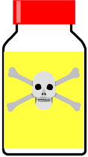

Aluminium
Argon
Arsenic
Barium
Boron
Bromine
Calcium
Carbon
Chlorine
Chromium
Cobalt
Copper
Fluorine
Gold
Helium
Hydrogen
Iodine
Iron
Lead
Lithium
Magnesium
Manganese
Mercury
Neon
Nickel
Nitrogen
Oxygen
Phosphorus
Potassium
Silicon
Silver
Sodium
Sulphur
Tin
Uranium
Zinc
SCORE /36



